**AWS Task-4**

**STEP 1: -** Create EC2 instance with Linux AMI

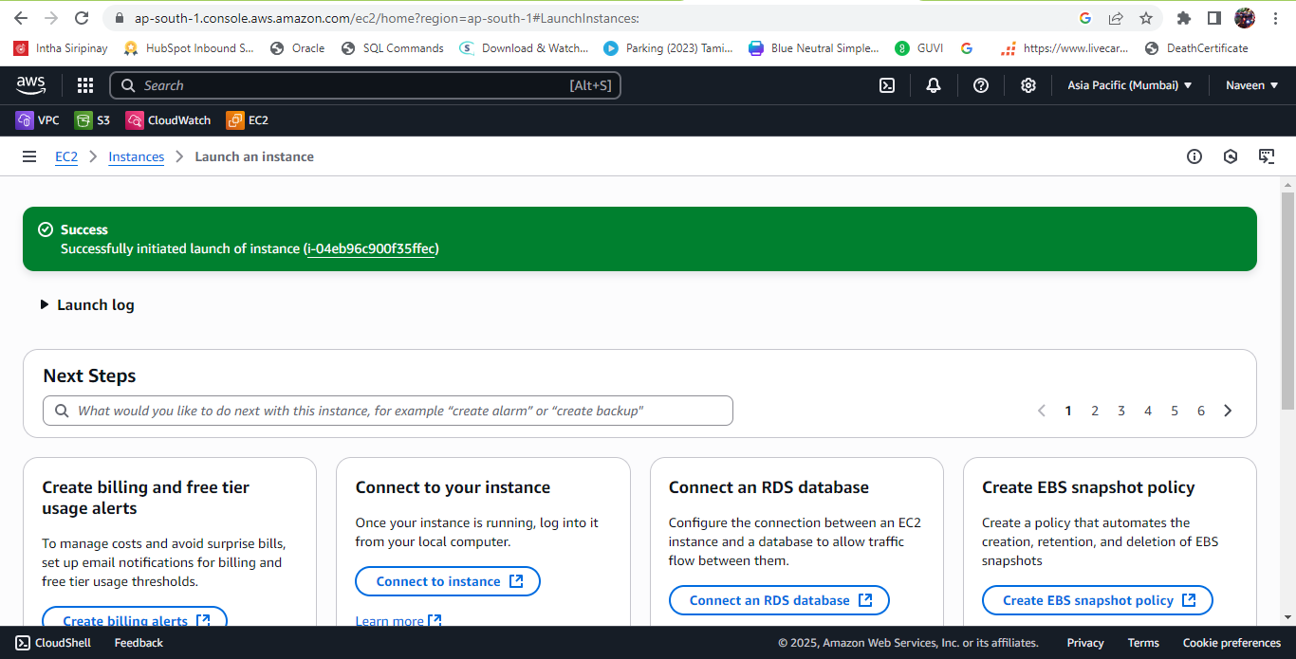

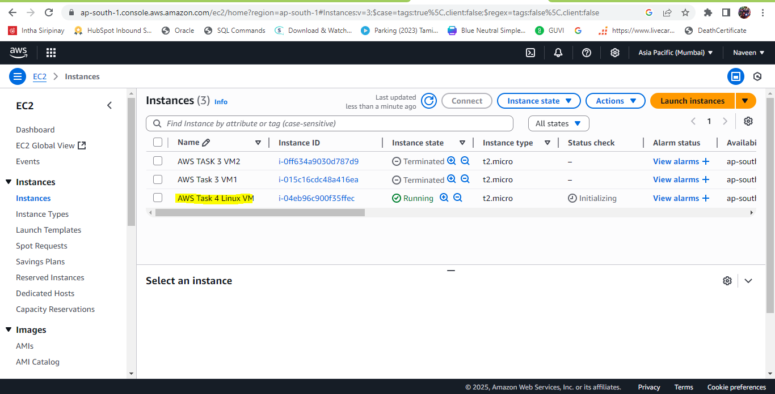

**STEP 2: -** Create another EC2 using Windows VM

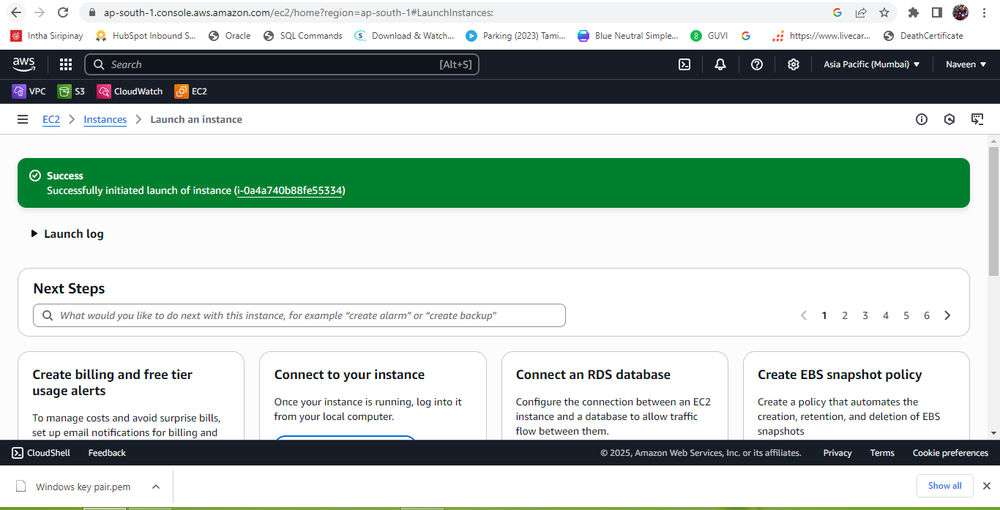

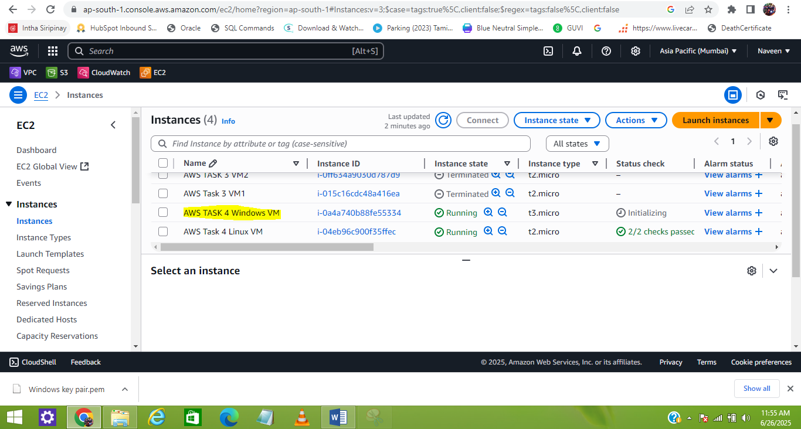

**STEP 3: -** Connect to each VM and install the web server

LINUX VM Screenshot

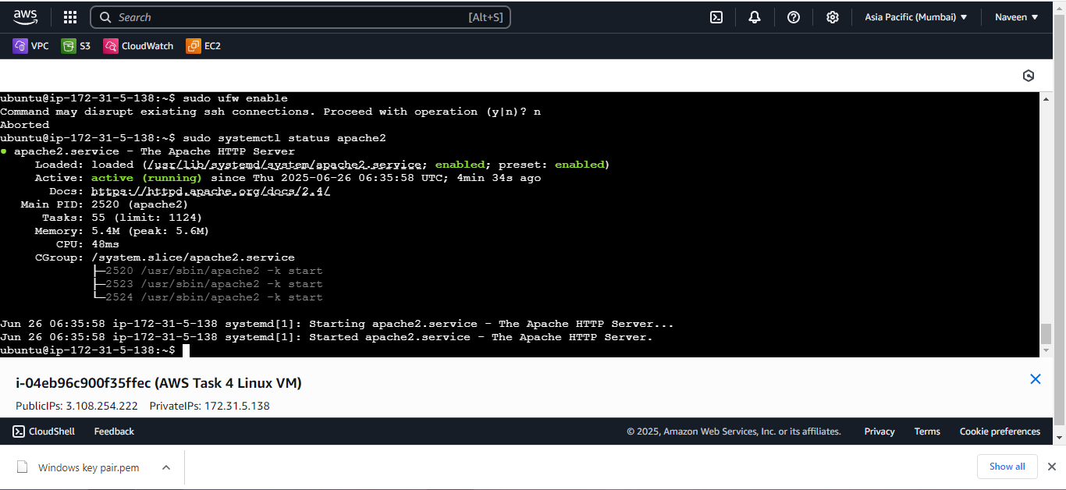

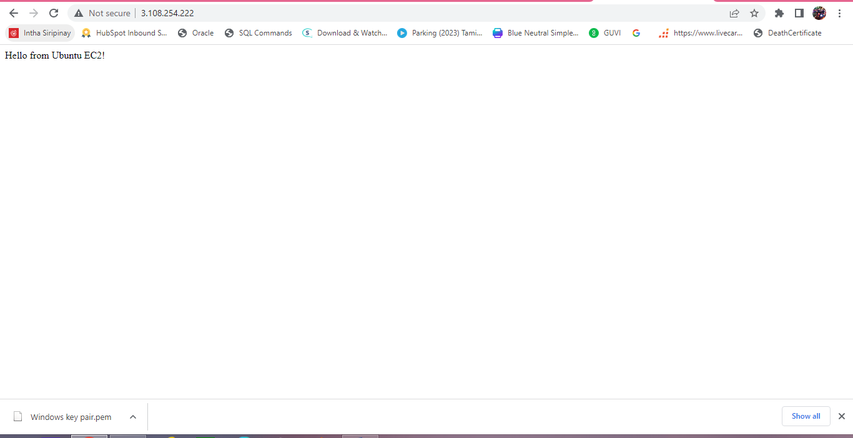

WINDOWS VM Screenshot

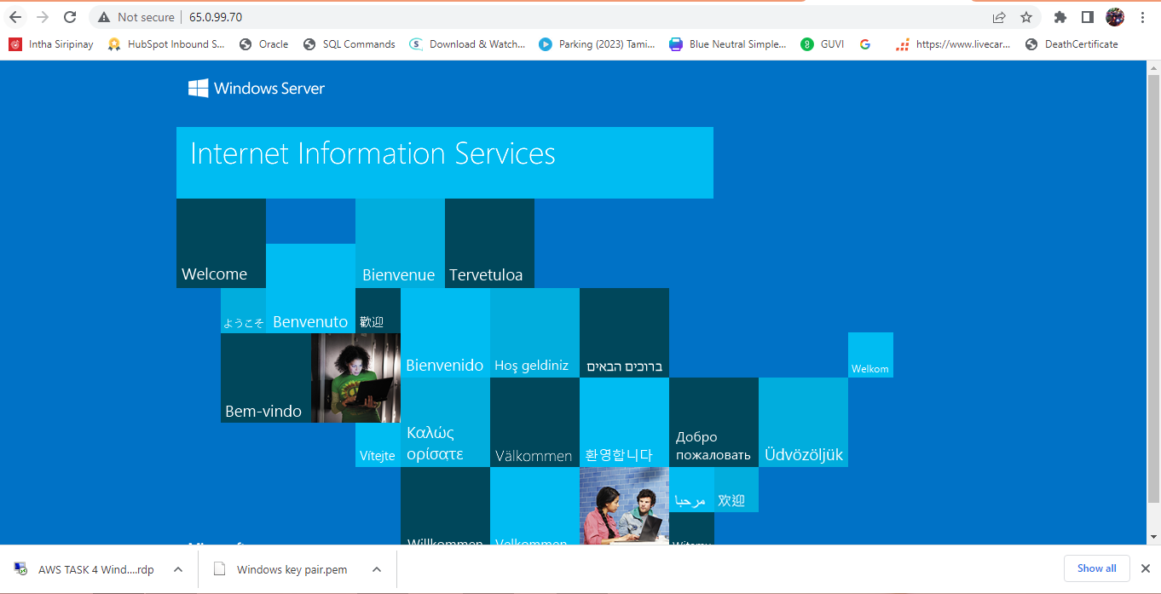

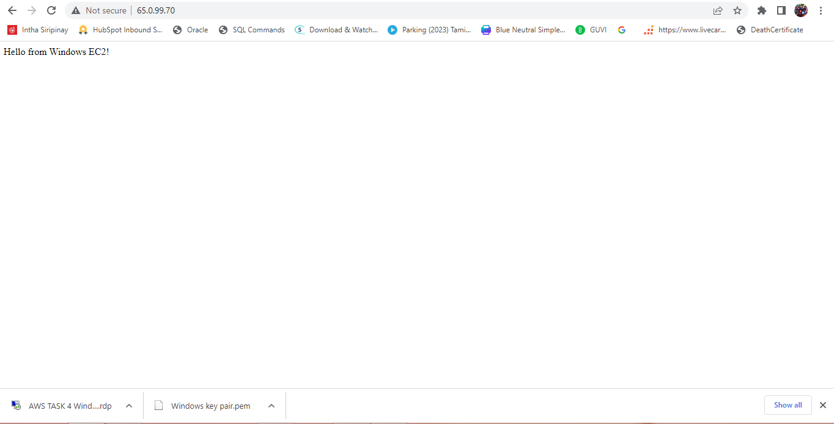

**STEP 4: -** Creating an EBS volume of 5 GB for each instance Linux and Windows

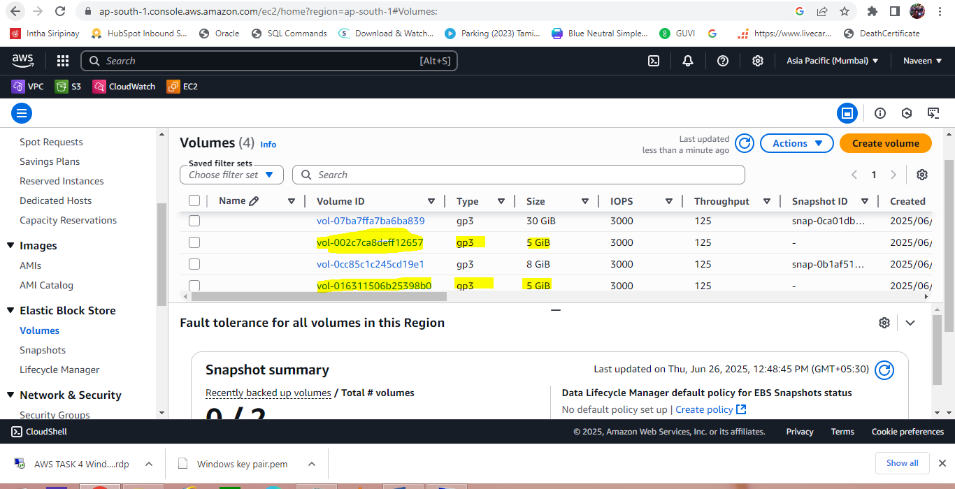

**STEP 5: -** Attaching the volume to both VM’s

Linux VM

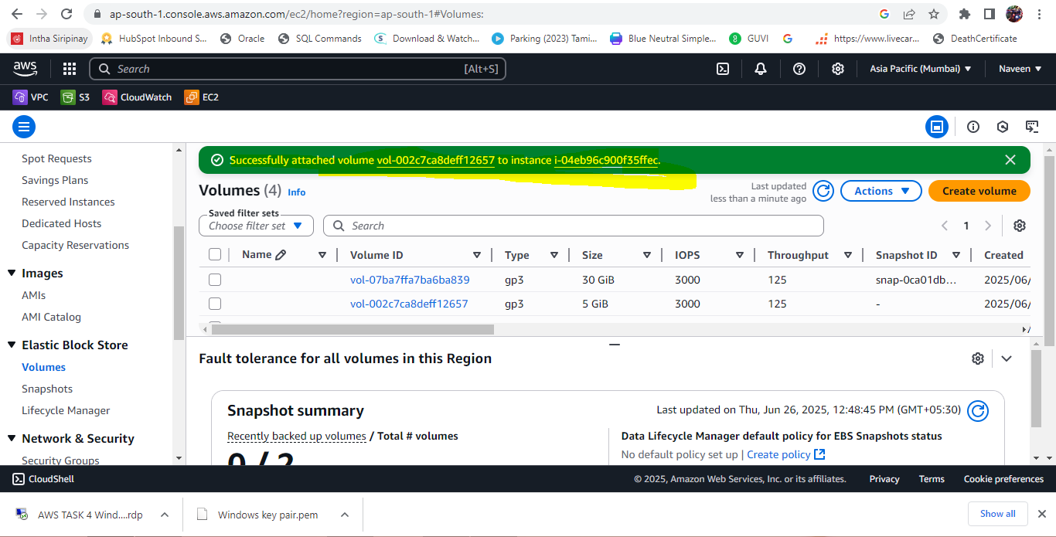

Windows VM

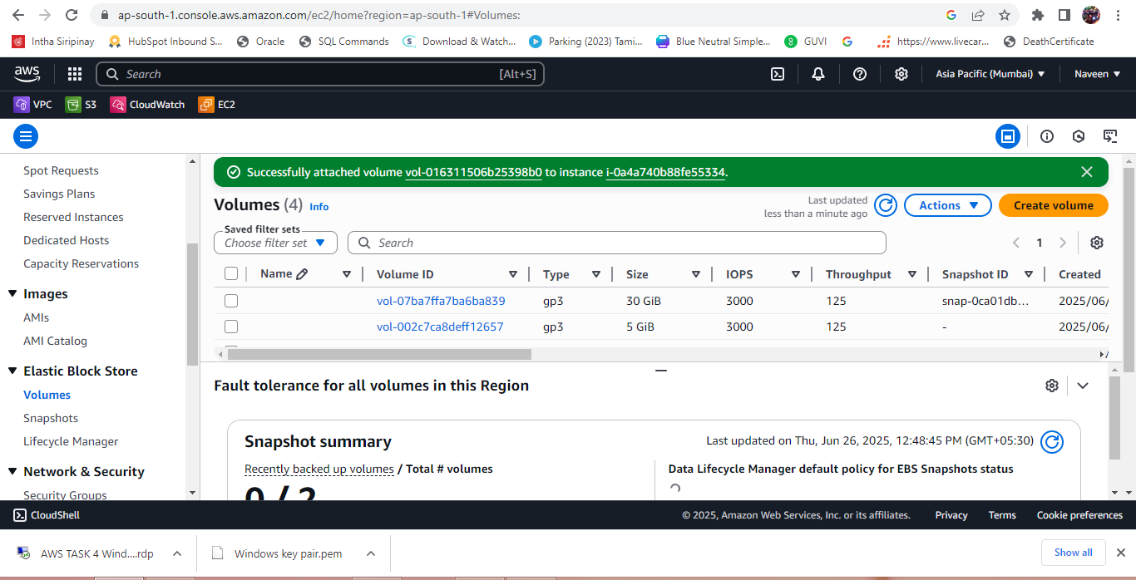

**STEP 6: -** Attaching it to an EC2 machine (Linux and Windows)

Linux VM

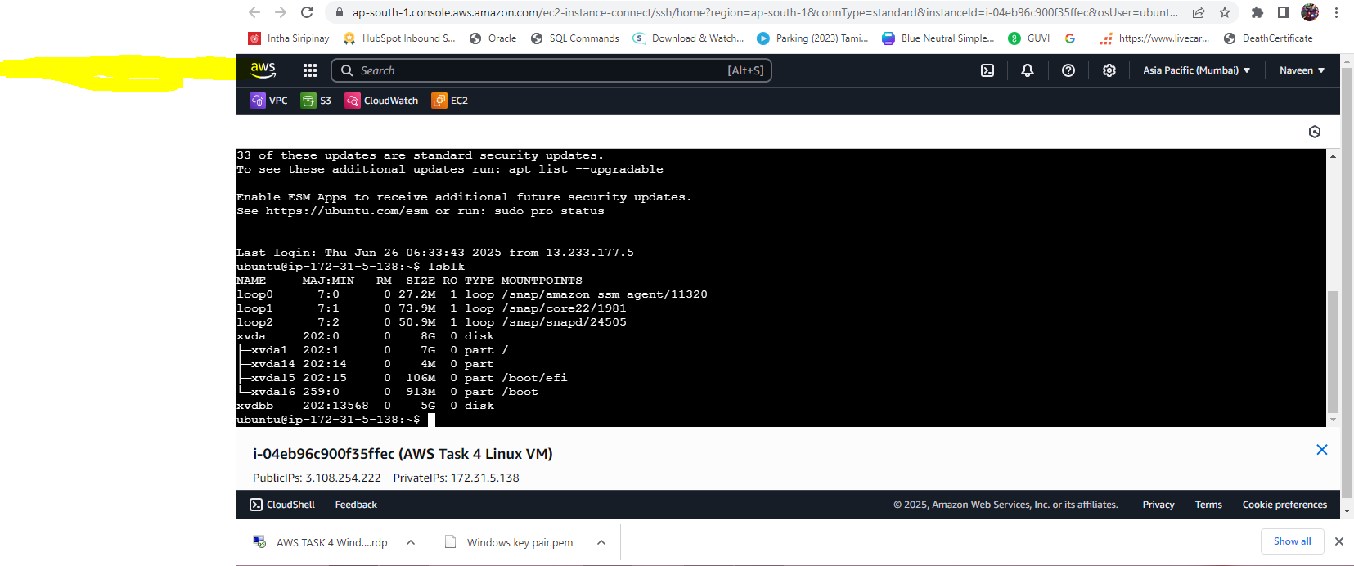

Mounting the volume

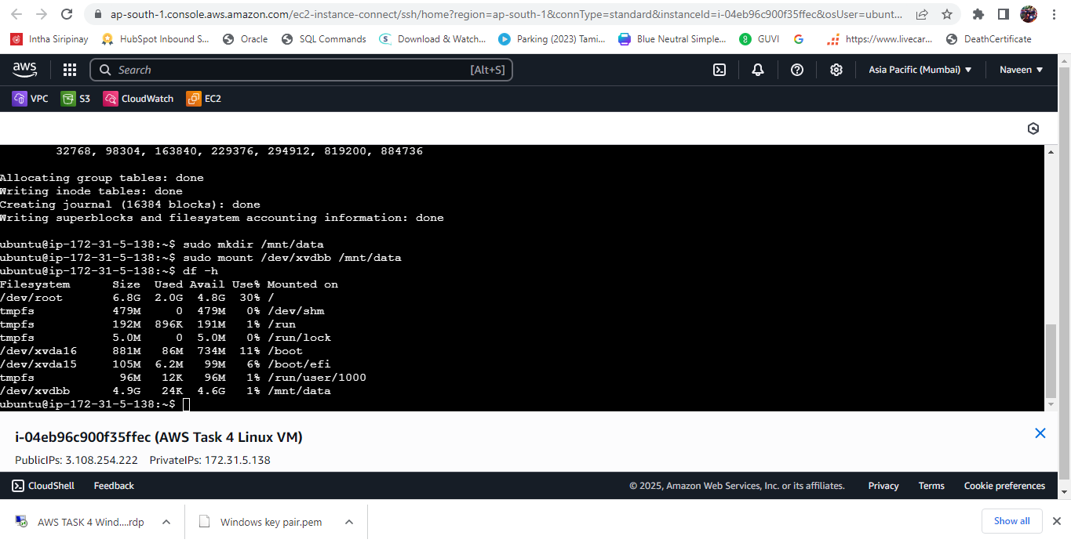

Windows VM

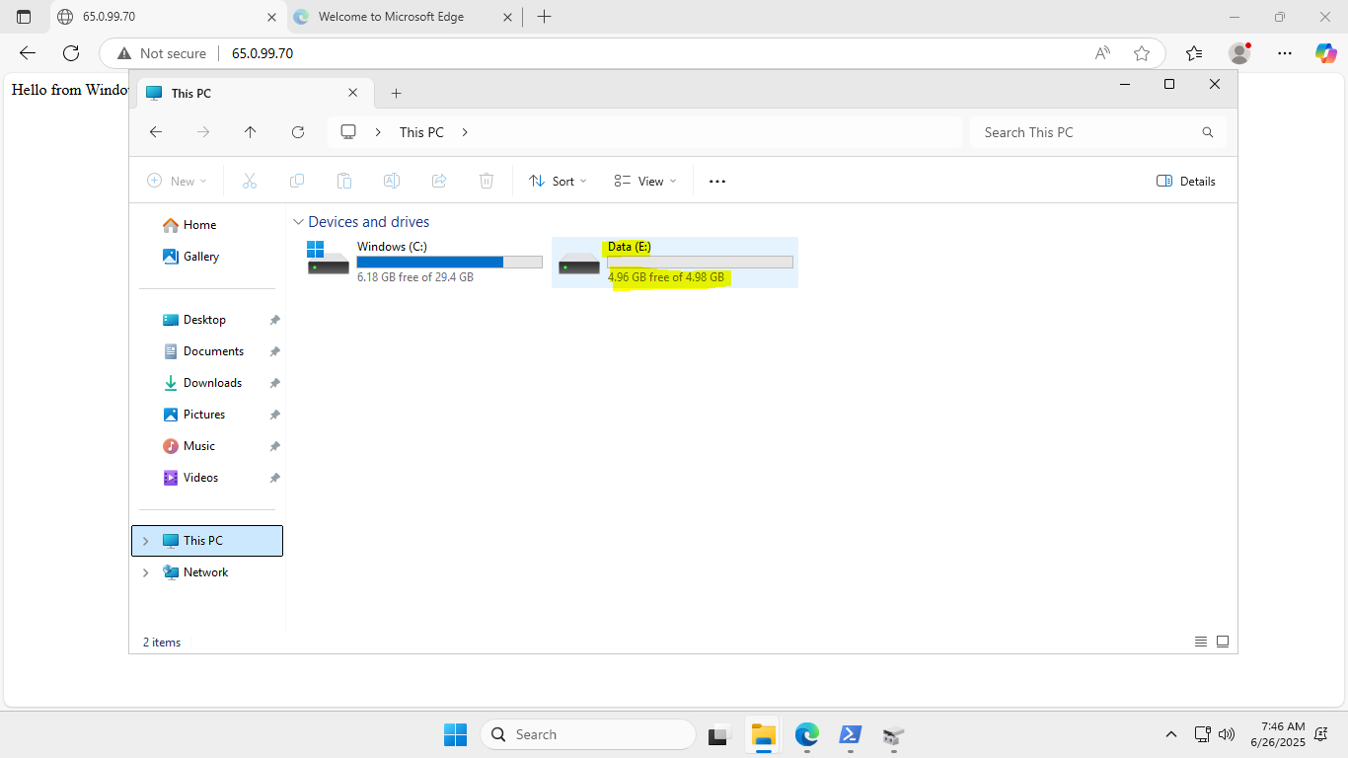

**STEP 7:-** Take a snapshot for both VM’s

Linux VM

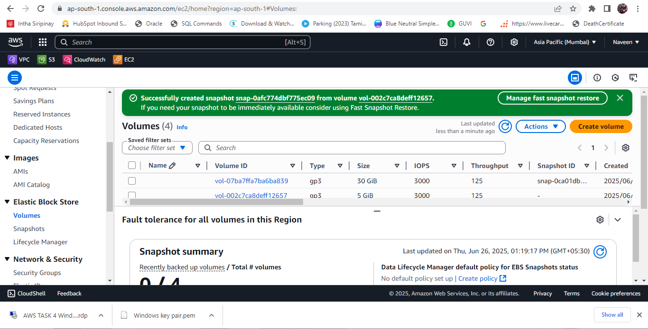

Windows VM

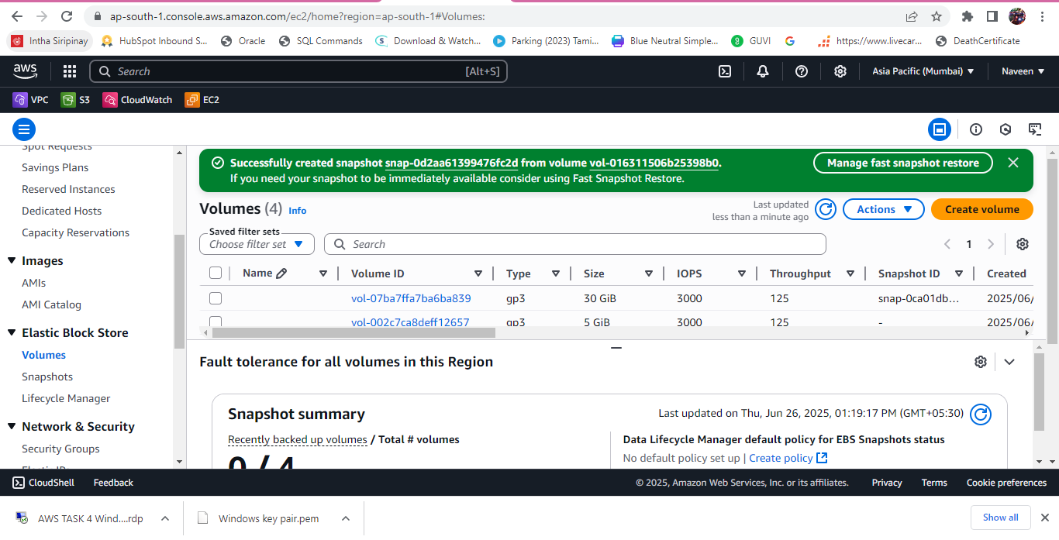

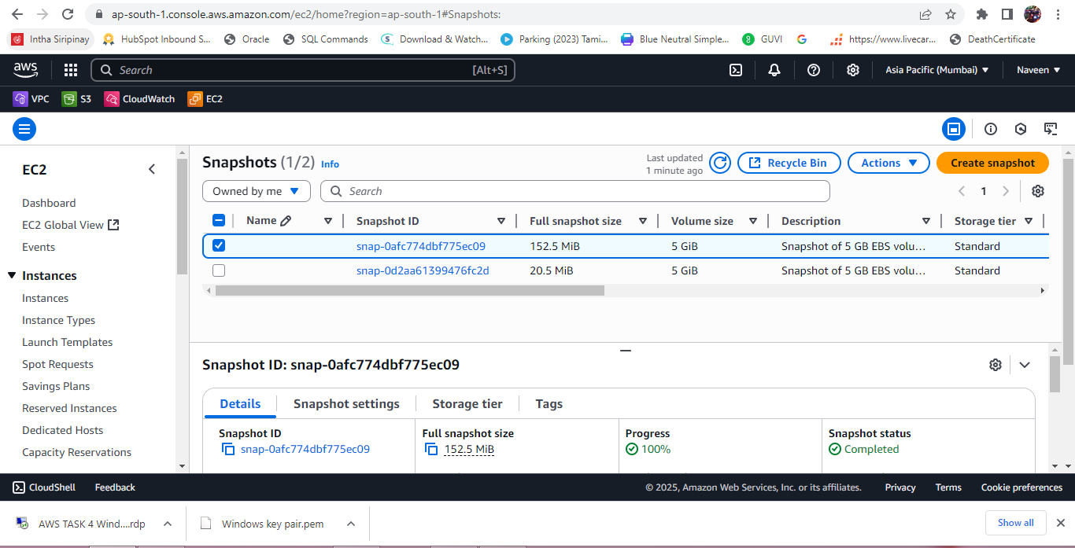

**STEP 8:-** Created an EBS volume using the taken snapshot.

